**Personal Calendar**

**User Manual**

Developed By: Thomas Morris

Contents

Add Event 3

Delete Event 5

Edit Event 7

View Event 10

View Monthly Event 11

# Add Event

1. Select a date from the monthly calendar.

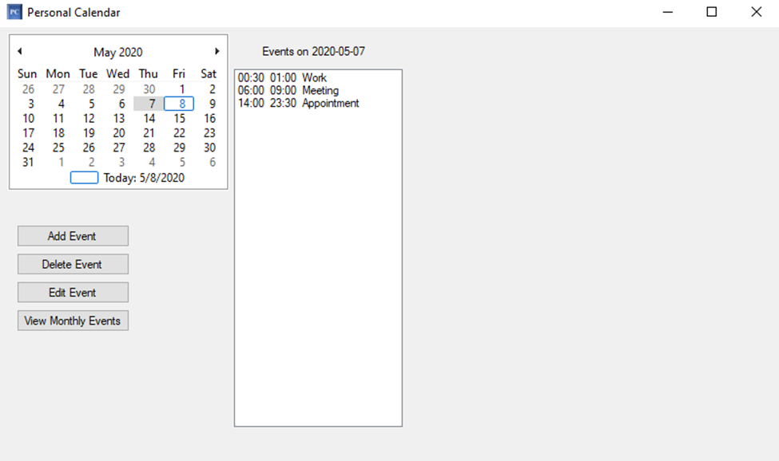

1. Once a date has been selected, press the “Add Event” button.
2. Enter the event title, starting time, ending time, location, and description into the form.

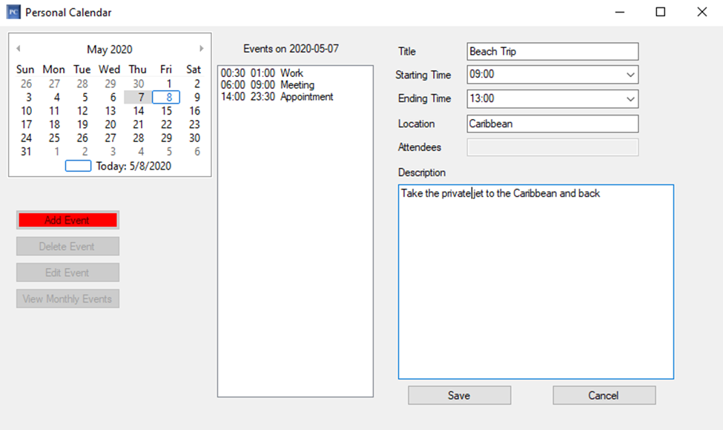

1. Select the save button to save the event to the calendar on the selected day. Select the cancel button to leave the add event function.
2. The system will display a message about the status of the save.
3. The message, “the new event has been saved to database successfully” means the new event has been added to the calendar.

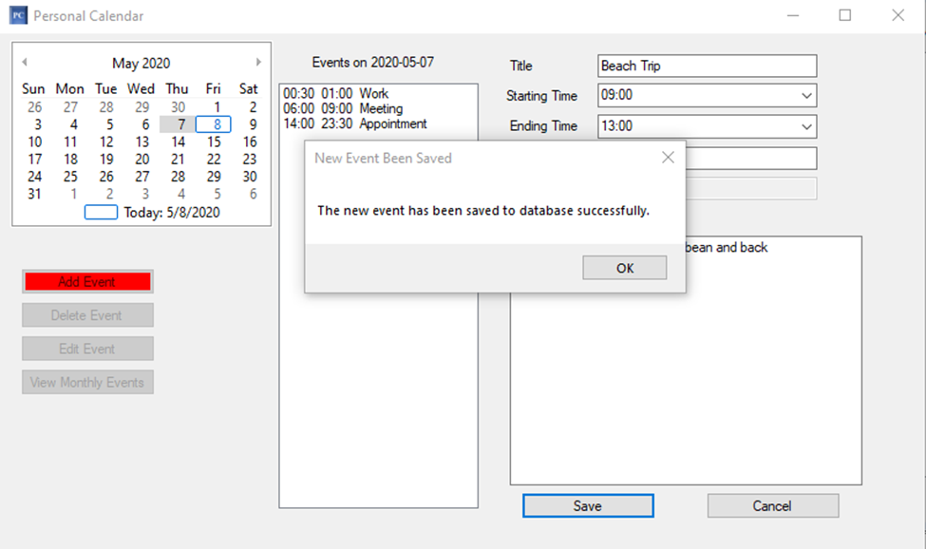

1. If there is a conflict, then the system will display the error message “the new event has time conflict with some existing event. Please double check starting and ending time.” After clicking okay, then either cancel adding the event or update the event values to resolve the conflict.

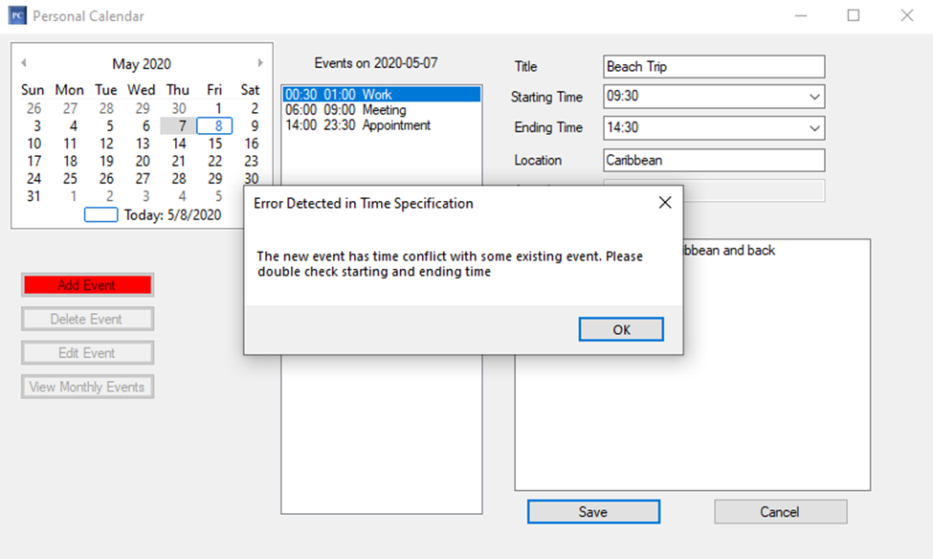

# Delete Event

1. Select a day from the monthly calendar to view events for that date.

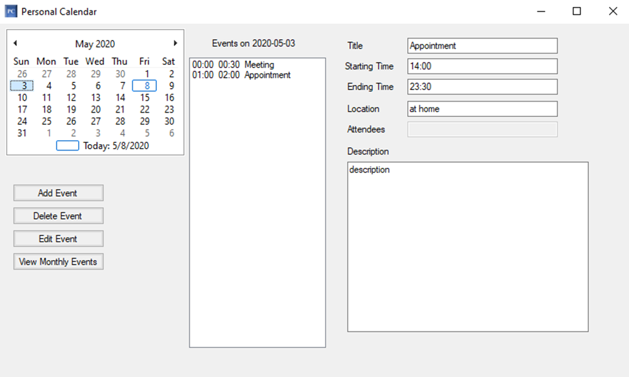

1. From the event list, select the event to remove from the calendar.

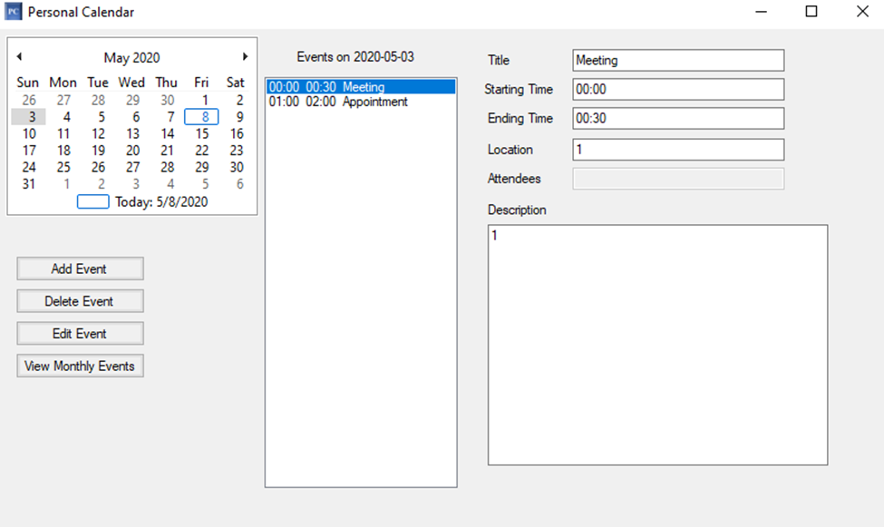

1. Select the “Delete Event” button.
2. A prompt will appear that asks, “Do you really want to delete this event?”
3. To delete the event, select “Yes.” The event will then be deleted from the database.

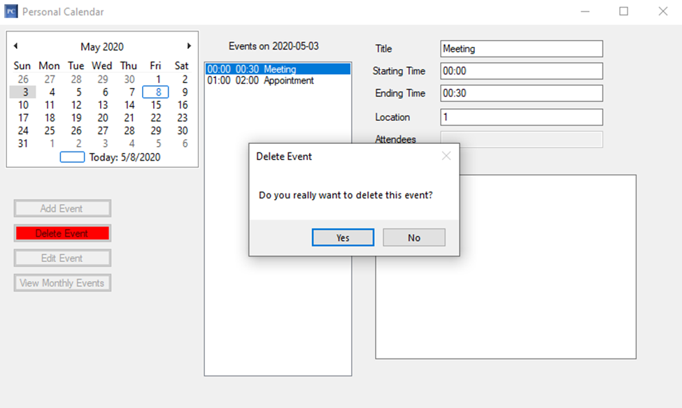

1. To not delete the event, select “No.” No changes will be made to the selected event.

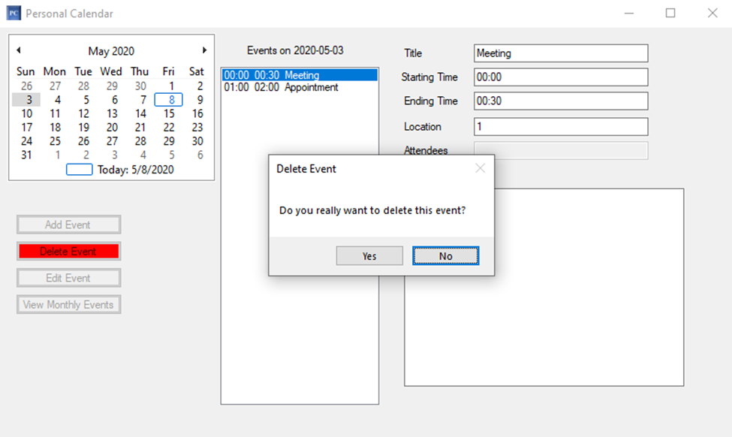

# Edit Event

1. Select a day from the monthly calendar to view events for that date.

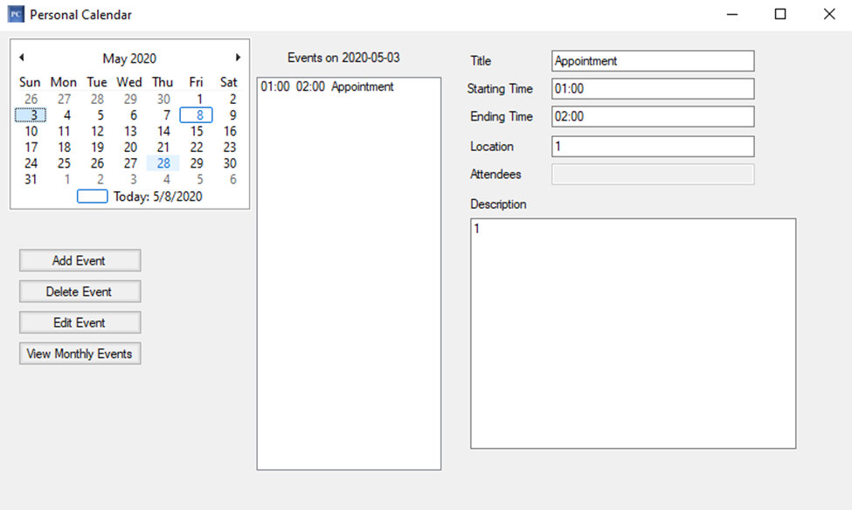

1. Select the event to edit from the list of events.

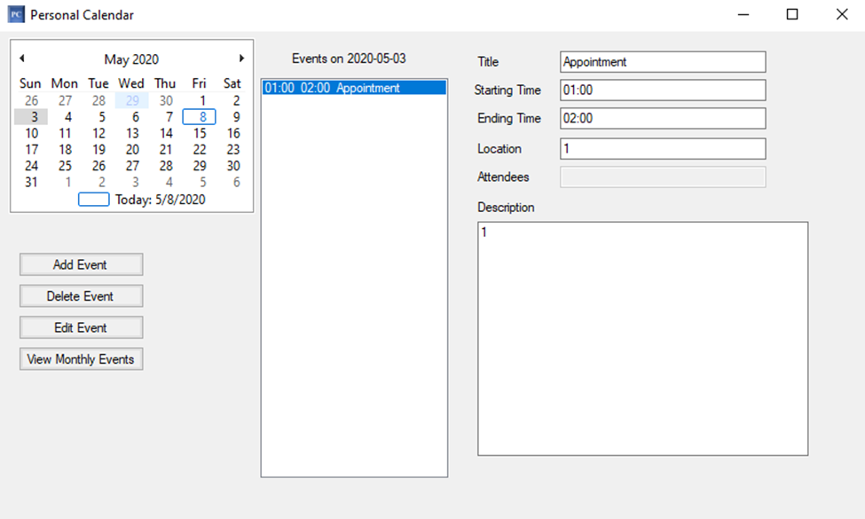

1. Select the “Edit Event” button.
2. A prompt will appear that asks, “Do you want to edit this event?”
3. To open the event for editing, select “Yes.”

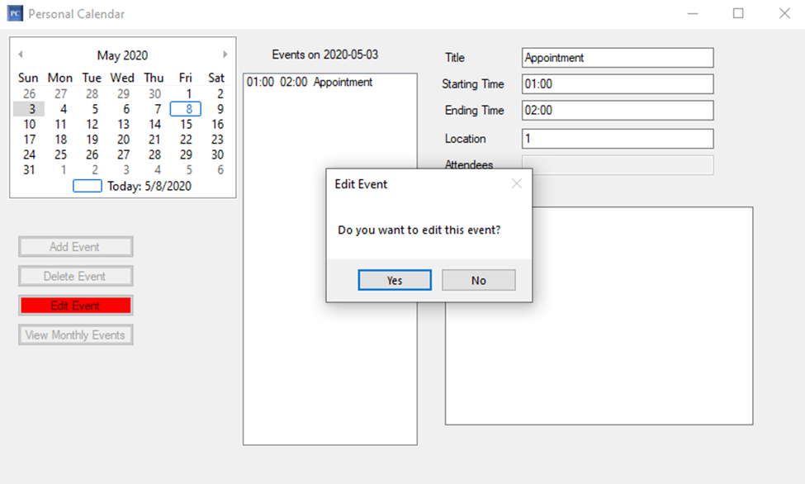

1. To not edit the event, select “No.”

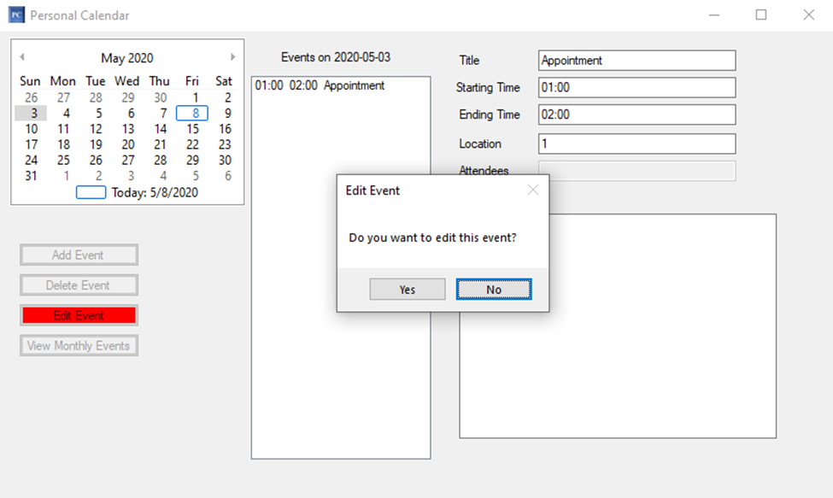

1. Put the new event information into the form and click “Save.” To cancel editing select “Cancel.”
2. The system will attempt to save the edited event information into the database. If there is no conflict then the message, “The event has been edited in the database successfully” will appear.
3. Otherwise, when there is a conflict the message, “The new event has time conflict with some existing event. Please double check starting and ending time” will appear. After clicking “OK”, then either cancel editing the event or update the event values to resolve the conflict before clicking save again.

# View Event Details

1. To view an event, select a date from the monthly calendar to view all events for that date.

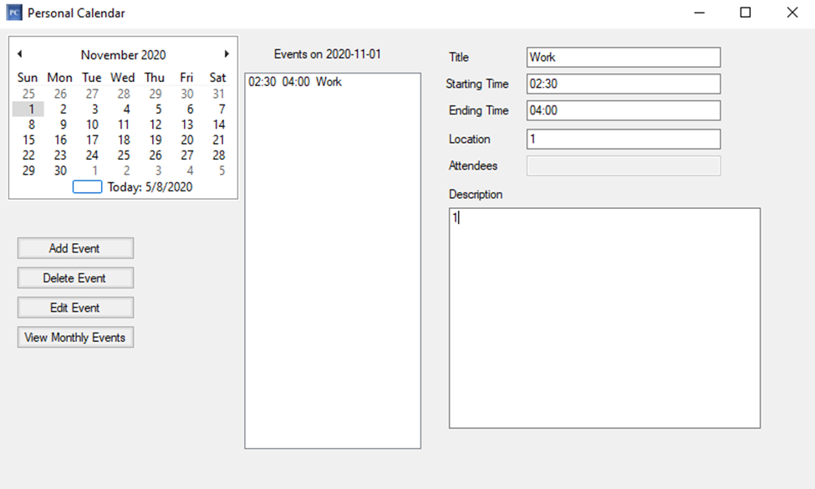

1. Select which event to view from the list of events.

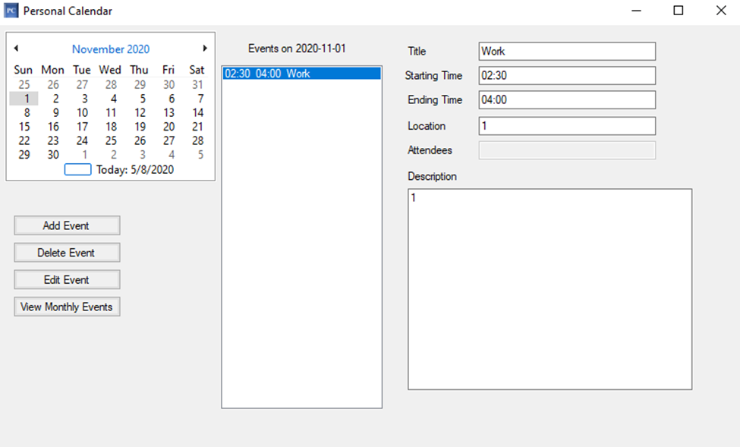

1. The system will display the contents of the event on the right-hand side of the screen.

# View Monthly Event

1. Select any day of the month you would like to view the monthly event list.

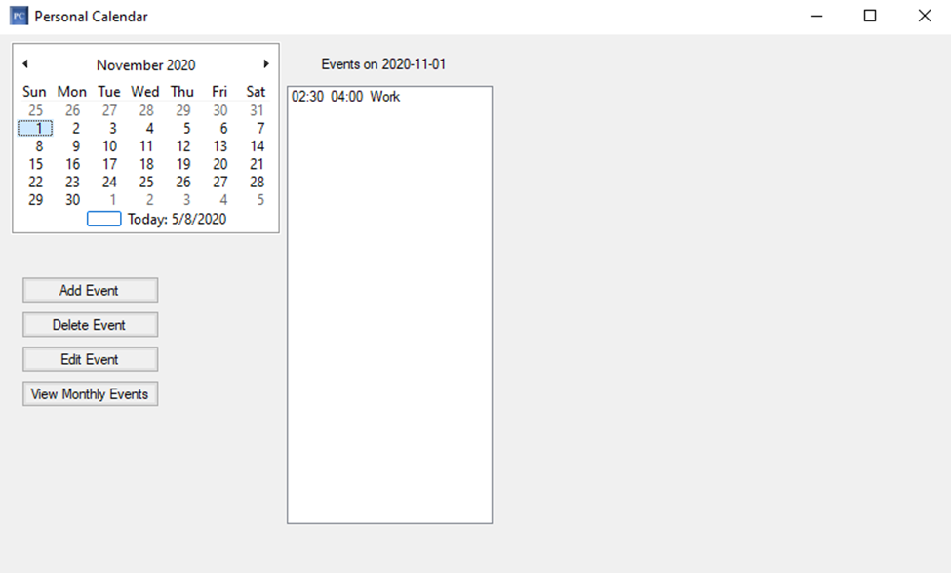

1. Select the “View Monthly Event” button.
2. The event list will update will all events for the selected month.

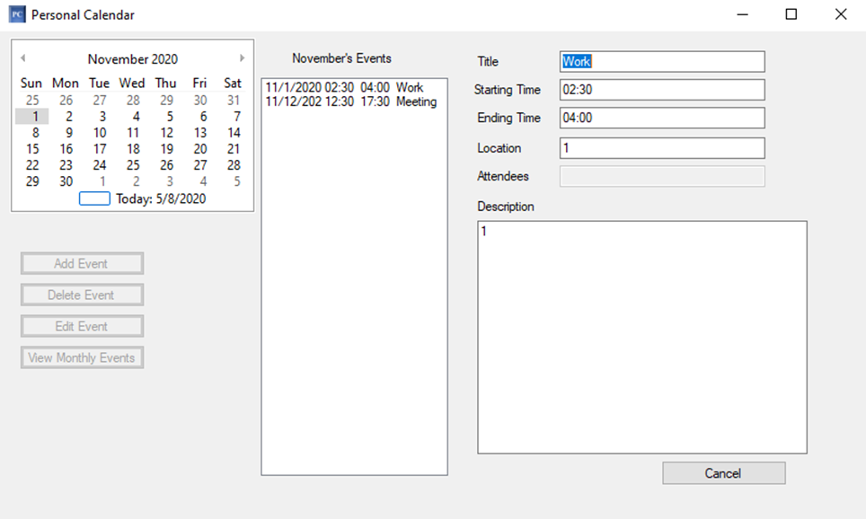

1. Select an event from the monthly event list to view its details.
2. Select the cancel button to return to the events for today’s date.